ixium
XES-BR Endoscopes
User Manual

Contents
Package Contents 2
Overview 2
Light Dial 2
LEDs 2
How to Use 3
Software 3
Viewing Live Video 3
Still Struggling? 4
Recommended 4
Other 4

Package Contents
- XES-BR Endoscope

Overview
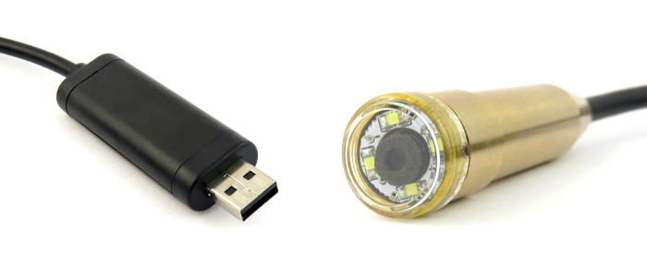
LEDs
Light dial
Figure 1

Light Dial
Use the light dial to adjust the brightness of the 4 LEDs built in to the lens of the endoscope. This will help you get the exact light level you need whilst in use.

LEDs
There are 4 LEDs within the lens to light your way whilst you are using the endoscope. As already mentioned the brightness can be adjusted to suit the area of use.

How to Use

Software
Download and install amcap from http://www.ixium.co.uk/downloads.html
You will find it under the support link for the XES-BR endoscope.

Viewing Live Video
Plug your endoscope in to your computer and open amcap.
Figure 2
Go to the menu in the top left corner of the screen (Figure 2), you should see Devices in this area. Click on Devices and select USB2.0 PC Camera, you may have something else selected by default like a webcam.
Once you have selected the endoscope you will be able to view the footage live.

Still Struggling?
If you are still struggling to understand how this item works you can get in contact via the following methods.

Recommended
Email: support@ixium.co.uk

Other
Telephone: 0115 8716899

