ixium
iXium XWSC-4 Wifi Clock
User Manual

Contents
Contents 1
Package Contents 2
Before You Start 2
Overview & Basic Setup 3
Control Buttons 3
Set Time 3
Alarm Function 4
Micro SD Card Slot 4
Battery and Charging 4
Indicator & WiFi Button 4
Connecting to the Camera 5
Direct Connect 5
Internet Connect 8
Camera Settings 10
Timestamp 10
Video Quality and Recordings 11
Alarm (motion detection) 12
Live View 14
Viewing Files 15
Still Struggling? 16
Recommended 16
Other 16

Package Contents
- iXium XWSC-4 Wifi Clock
- USB Cable (USB to Mini USB)

Before You Start
Make sure you removed the battery tab and have charged the device for 8 or more hours prior to use.
It is recommended that you charge for at least 24 hours; however we know this is not always possible.
Turn over for charging instructions…

Overview & Basic Setup
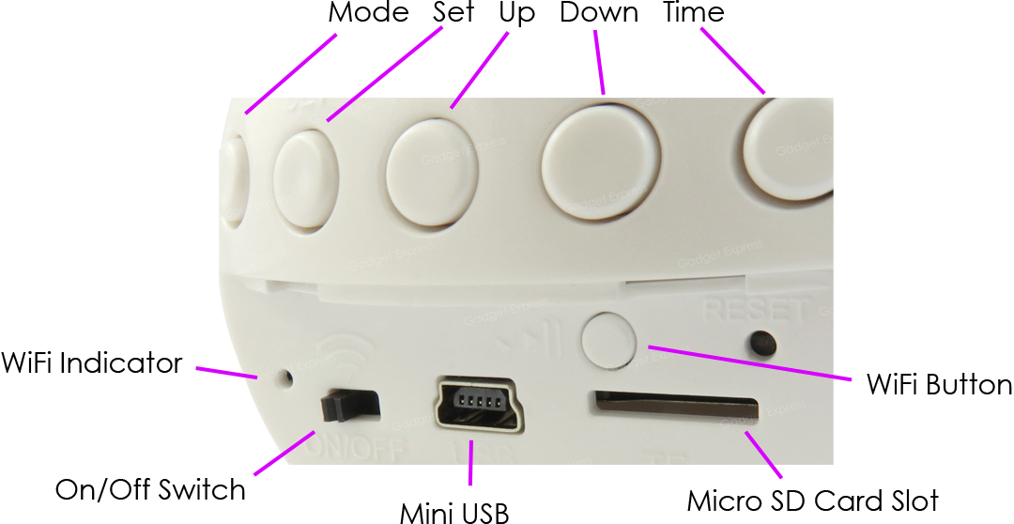
Figure 1

Control Buttons
You have a number of control buttons on the top back of the clock; in order they are as follows:
Mode | Set | Up | Down | Time
You will be able to use these button to change both the date/time and alarm functions of the clock.

Set Time
When you first turn the clock on you will need to change the time and date shown on the display. To do this press the Set button on the back of the clock.
You will first get the option to change the year, use the Up and Down buttons to get the correct year. Once you have got the right year showing on the display press Set which will move you on to the month.
Again use the Up and Down buttons to get the correct month; once done press Set and change the date in the same manner.
After you have set the year, month and date you can move on the change the time by pressing the Set button again. First you have the option to change the hour followed by the minute; this is done just like changing the date. When finished setting up the time press Set and you will exit back to the main display which should now be showing the correct date and time.
The process above should be as follows:
Set (start) > Year > Set > Month > Set > Date > Set > Hour > Set > Minute > Set (exit)

Alarm Function
After you have completed the date and time set up you may want to add an alarm; if not then you can skip this step.
To add an alarm press the Mode button, this will show up a screen displaying the following “--:--“.
Setting up an alarm is a similar process to changing the date and time.
Pressing Set will enable you to change the hour and then the minute; after choosing the time you want the alarm to go off you can set the snooze interval followed by the alarm sound. This whole process is done by using the Up and Down buttons as previously used for changing the date and time.
The process above should be as follows:
Set (start) > Hour > Set > Minute > Set > Snooze Interval > Set > Alarm Sound > Set (exit)
The alarm by default will not be activated. After setting up the alarm press the Up button to activate it; this will not have the snooze function enabled.
If you want the snooze function enabled press Up a second time.
Do deactivate the alarm altogether press Up a third time.
The activating process should be as follows:
Up (activate) > Up (activate with snooze) > Up (deactivate)
If you are happy with your alarm set up press Mode and you will be returned to the date/time screen.

Micro SD Card Slot
For the clock to record any footage you must insert a Micro SD card in to the slot in the back; you can use any Micro SD card between 4GB and 32GB. If you need a Micro SD card then take a look here: www.wecostless.co.uk > electronics > memory cards

Battery and Charging
Supplied with the clock is a USB cable which enables you to charge the internal battery. This can be done via a computer or a USB mains charger.
The internal battery will last up to 4 hours when not plugged in to a power source.

Indicator & WiFi Button
You have one main indicator and button on the back of the clock. The button is to enable and disable to clock’s WiFi and the indicator shows the status of the Wifi.

Connecting to the Camera
To get the clock recording you will need to connect to it via your phone or tablet. To do this you will need to enable the clock’s WiFi.
To activate the WiFi press the WiFi button; after the indicator has done the following sequence wait 5 minutes prior to connecting to the WiFi:
Red > Blue > Red & Blue Flashing (indicator will carry on flashing)
You will also need to download an App called P2PLiveCam; it is free and available on both the Apple Store and Google Play. Figure 2 shows what you are looking for.
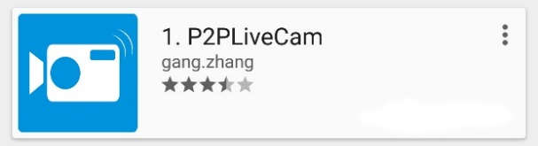
Figure 2

Direct Connect
First off you must connect your phone or tablet to the clock’s Wifi. The Clock should be named “CM*****”. Each camera should replace the * with a random selection of letters/numbers. Figure 3 shows an example of how the camera might appear in your WiFi list.
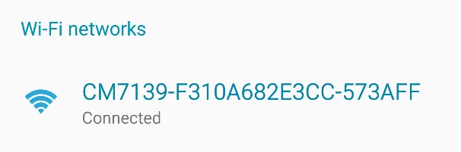
Figure 3
The Wifi should be an open network so you will not need to use a password for this section.

Once connected to the clock WiFi open the P2PLiveCam App on your phone. After the App has loaded you should be on the main window My Cameras as shown in Figure 4.

Figure 4
To add the camera you want to press the plus icon in the top right corner (highlighted in Figure 4).
Figure 5 shows the options you will be faced with; select Add new online camera. You will now have a window (Figure 6) enabling you to input camera details; select Search (Lan) from the list and your phone will search for the camera that you are connected to.
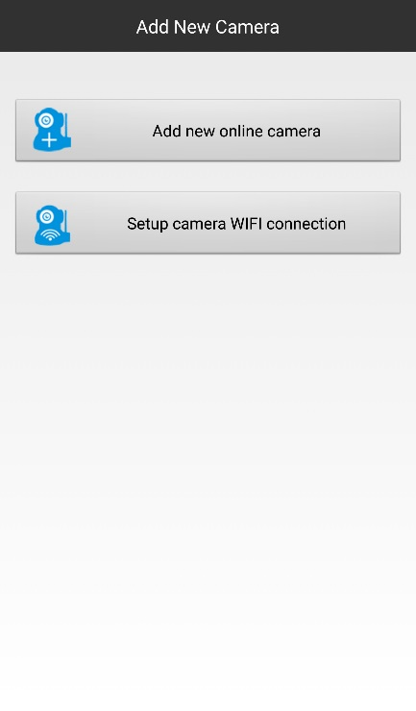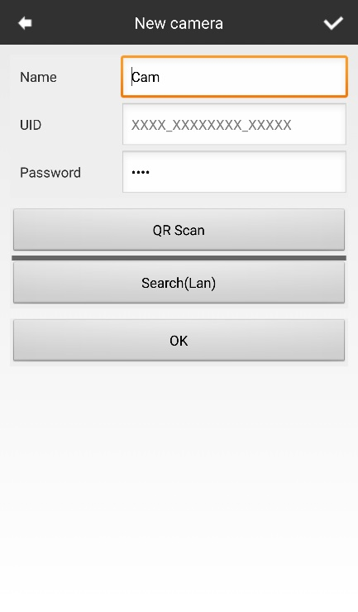
Figure 5 Figure 6

After your phone has found the clock on the WiFi it will appear in a list (Figure 7); select the clock and you will be returned to the previous window where you will now find the UID and Password filled in (Figure 8).
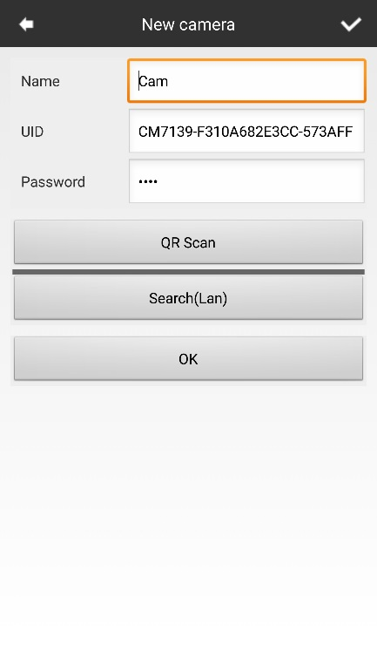
Figure 7 Figure 8
You can also change the name of the camera, this is useful if you plan on having a number of the cameras connected. Once complete press OK and you will be taken back to the My Cameras screen; instead of being blank you should now have a camera available as shown in Figure 9.
Figure 9
The camera is now connected to your phone/tablet.

Change Security Password (recommended)
For this to work you MUST be connected to the camera directly and have it available in the My Cameras list.
For security reasons you will want to change the password for the clock so others cannot connect to it.
Open the App and press the settings cog next to the camera, you will get a small menu pop up (Figure 10); select Advanced Config from the bottom of the list. You will be prompted for a password (Figrue 11), leave this blank and just select OK.
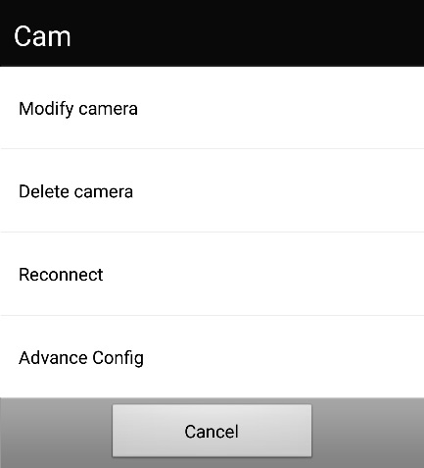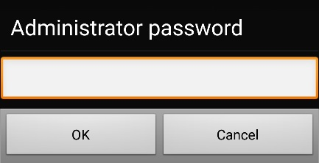
Figure 10 Figure 11
You now have access to all the clock’s camera settings as shown in Figure 12.
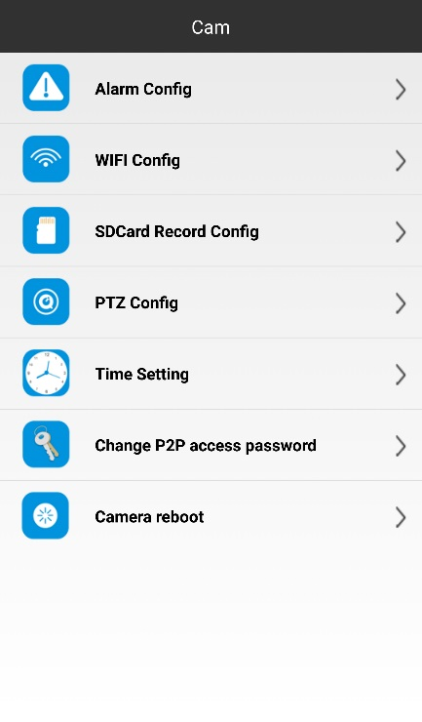
Figure 12

Select Change P2P access password, this will give you a window as shown in Figure 13.
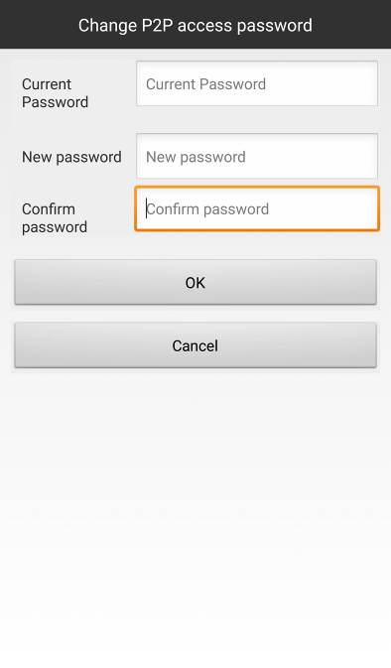
Figure 13
Type in the default password in to the first box and then type your new password in to the second and third. Once you have chosen a password tap OK and your password will update. If you get prompted checking if you want to change the password make sure you say yes.

Internet Connect
When connected to the cameras WiFi direct open the setting menu as previously shown in changing the security password. To connect the clock to the Internet select Wifi Config from the list.
The config window (Figure 14) will enable you to select the network you want to connect to (SSID); all available WiFi networks will appear in a list much like Figure 14.
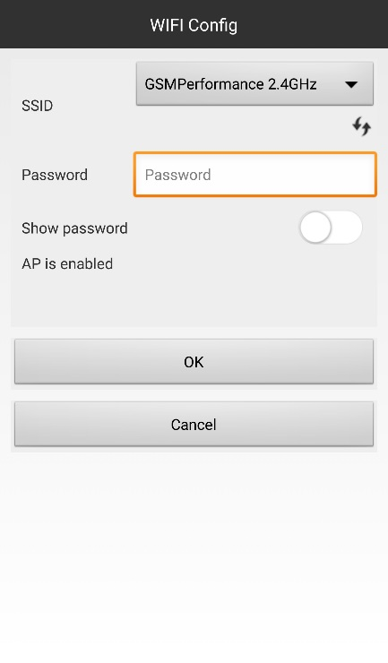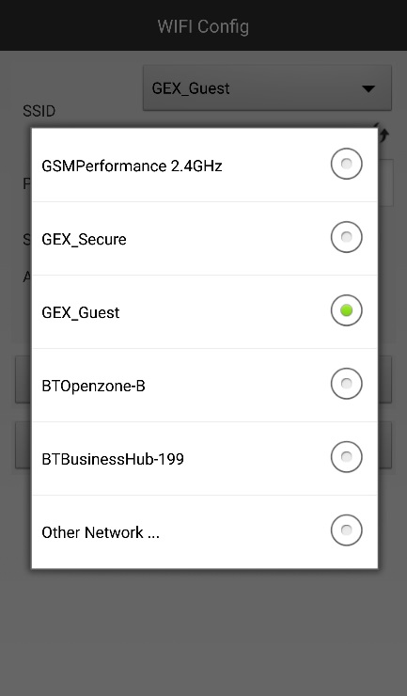
Figure 14 Figure 15
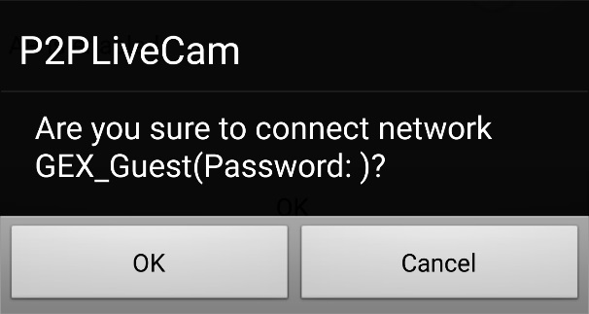
Figure 16
Select the SSID from the list and input the password for that network. When you select the OK you will be asked to confirm the connection (Figure 16), select OK again to confirm the connection and the clock’s WiFi will restart and attempt to connect to the WiFi network.
Exit the App and connect your phone back to your own router if it has not auto-connected by itself.
Do not open the App straight away, leave it 5 minutes prior to opening the App. After 5 minutes open the App and look in the My Cameras list to find the camera as connected and available to view.

Camera Settings
You can easily change many of the default settings on the clock from the same settings menu area as previously used to connect the clock to your WiFi router (Internet).
Figure 17

Timestamp
The first setting that you want to change is the timestamp shown on videos, to do this select Time Setting from the list. Updating the time is as easy as pressing the Camera Time Sync With App button (Figure 18).
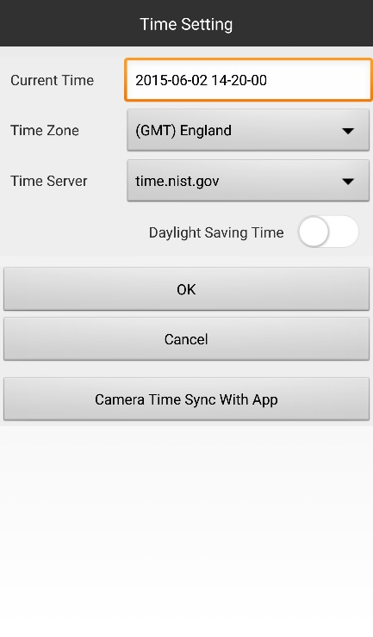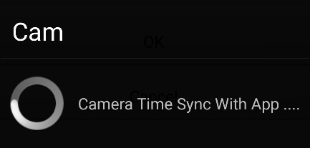
Figure 18 Figure 19

Video Quality and Recordings
After updating the time on the clock you can return the main menu and change the video settings, video settings can be changed in the SDCard Record Config. Within the video settings, Figure 20, you are able to change a number of settings including when to record and what resolution you want.
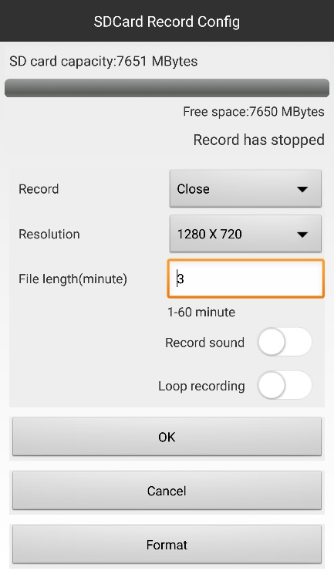
Figure 20
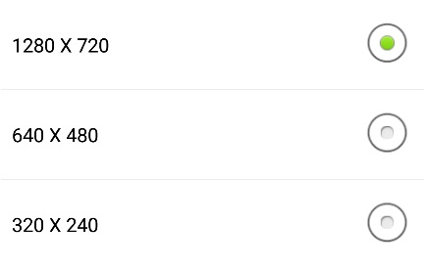
Figure 21 Figure 22
Figures 21/22 show you the options for when to record (Figure 21) and what resolution (Figure 22).
When to record?
- Close: Do not record
- On alarm: Only records when motion is detected
- All day: Constant recording
What resolution?
- 1280 x 720: High quality but takes up more space
- 640 x 480: DVD quality, not great but only uses a moderate amount of space
- 320 x 240: Low quality but can record more minutes per GB
The most commonly used combination is On alarm and 1280 x 720, this will get good quality video and only record when needed.
You also get the option to change the length of each video clip, whether to record sound or not and if you would like the loop recording feature enabled.
By default each clip will be 3 minutes long, this means that should the battery drain whilst in use you will not lose any footage. If you set the recording length to, for example, 30 minutes and the battery drains after recording 17 minutes worth then the whole recording will be wiped. It is best to leave the recording time at the default 3 minutes; if there is still motion then a new file will start recording as soon as the current one has finished.
Having sound on the video is not always needed; if you do not want sound then the video files will be slightly smaller in size so you can record more video.
Loop recording, should you not already know, is where a camera can overwrite the earliest files when the memory is full. Loop recording is useful as you don’t ever need to delete the old recorded files as they are automatically deleted to make space for new ones. The only time you need to look at the files is when something has happened, in this case you would copy the files over to your PC for safe keeping.

Alarm (motion detection)
The On alarm function has already been mentioned in the video settings, it is often known as motion detection.
In the main settings menu select Alarm Config, you will now have a number of options (Figure 23) to select from to get the best out of the clock.
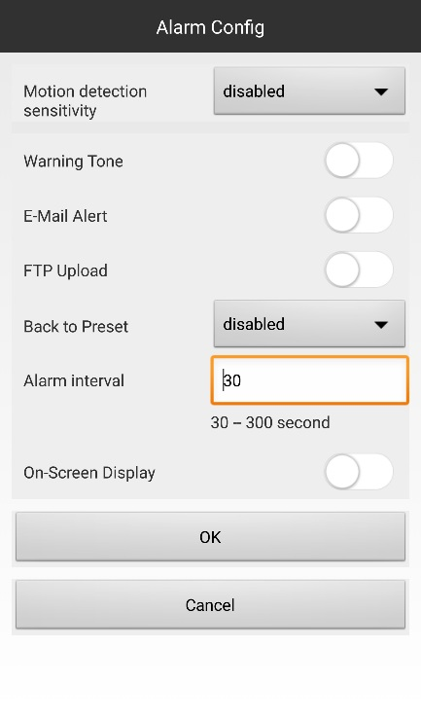
Figure 23

Your first option is whether you want motion detection enabled or not, it has different sensitivity levels as shown in Figure 24. If you want the clock to record at the slightest movement select level 1; if you want to it only activate when there is some obvious big movement then select level 7. Most users select level 4 as that is the mid-way point giving you a sensitivity that is just right for human activation.
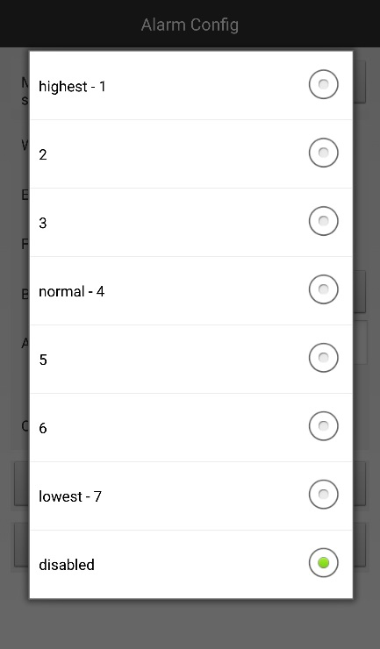
Figure 24
Another option you have is a warning tone, this will notify you of any movement if you have the app open or running in the background on your phone or tablet.
The alarm interval is for the warning tone and a feature that should be set up if you are using it; it can be set between 30 and 300 seconds. If you do not want to be plagued with notifications then you want to set this to a minimum of 180 seconds; this matches the default recording time of 3 minutes.
After you have set up the alarm and the notification interval you are ready to go, press OK and you will exit this area.

Live View
When in the My Cameras area just select the camera and you will be able to view the camera stream live as shown in Figure 25.
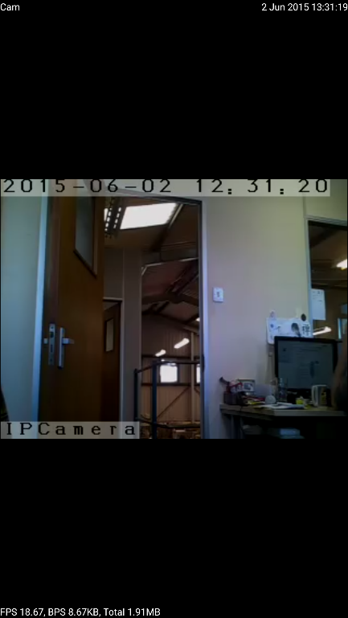
Figure 25
If you tap the live stream you will get some options appear. The top 3 controls (Figure 26) effect the playback of the video, first off is the picture quality.
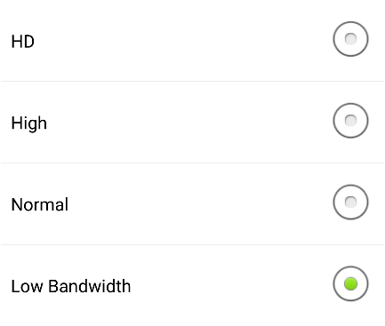
Figure 26 Figure 27
You have 4 options for the video quality: HD, High, Normal and Low Bandwidth. By default it will be Low Bandwidth but you can change it to any you want, obviously HD is the best streaming quality.
HD should only be used when you have your phone or tablet on a WiFi network as streaming in HD can eat through your data plan very fast. If running through a mobile network only use Low Bandwidth.
The next two options are brightness and contrast. Brightness will make the image lighter and darker whereas the contrast will make image richer or more washed out in colour.
Figure 28
The options at the bottom of the window, in order of appearance, are as follows:
- Hear sound from the clock *
- Send sound (not supported by this camera)
- Screenshot *
- Manually record video *
- Move image horizontally (only works on certain streams)
- Move image vertically (only works on certain streams)
- Flip image horizontally
- Flip image vertically
Only 3 of these options are commonly used all of which are marked with *. Sometimes you want to stream sound from the clock, this will use more data. Taking a screenshot of something can be useful for evidence as can a video. If you have set the clock up to record on motion detection then you will not likely used these two options.

Viewing Files
To view the files back take the memory card out of the clock, put it in the USB card reader provided, plug it in to your computer and then view the video files as if you had just put in a USB stick to your computer.

Still Struggling?
If you are still struggling to understand how this item works you can get in contact via the following methods.

Recommended
Email: support@ixium.co.uk

Other
Telephone: 0115 8716899

