ixium
iXium WiFi Smoke Alarm Camera
User Manual

Contents
Package Contents 2
Before You Start 2
Overview & Basic Setup 3
Indicator 3
Battery and Charging 3
Connecting to the Camera 4
Via Phone or Tablet (direct connect) 4
Via Phone or Tablet (internet connect) 7
Via Computer (LAN connect) 9
Camera Settings 12
Live View 14
Via Phone or Tablet 14
Via Computer 15
Viewing Files 16
Via Phone or Tablet (camera screen captures) 16
Via Computer (computer recordings) 17
Still Struggling? 18
Recommended 18
Other 18
Appendix 19
P2PCamWin Install 19

Package Contents
- WiFi Smoke Alarm Camera
- USB Cable (USB to Mini USB)
- Bracket
- 2 x Screws

Before You Start
Make sure you have charged the device for 8 or more hours prior to use. It is recommended that you charge for at least 24 hours; however, we know this is not always possible.
Turn over for charging instructions…

Overview & Basic Setup

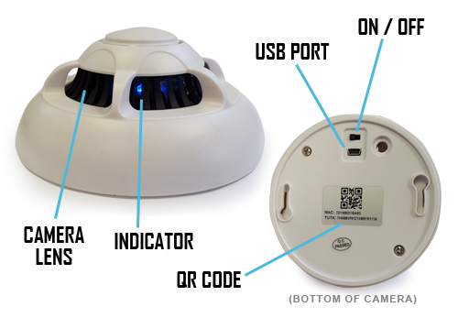
Figure 1

Indicator
Once you have switched the camera on the blue indicator inside the smoke alarm will light up. The indicator signifies that the smoke alarm is ready for use.

Battery and Charging
Supplied with the camera is a USB cable which enables you to charge the internal battery. This can be done via a computer or a USB mains charger.
The internal battery will last up to 4 hours when not plugged in to a power source.

(turn over)

Connecting to the Camera
To view what the clock is seeing you will need to connect to it via your phone, tablet or computer. To do this simply flick the switch on the back to the on position. Once the camera is on a blue indicator will appear.
If you are connecting to the camera via your phone or tablet you will need to download an App called P2PCamLive; it is free and available on both the Apple Store and Google Play. Figure 2 shows what you are looking for.
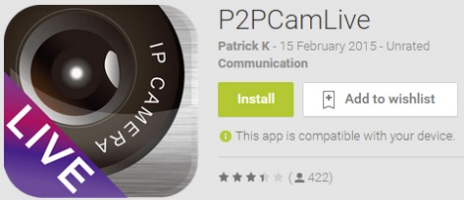
Figure 2
If you are connecting to the camera via your computer you will need to download and install P2PCamWin via the software download on our website. Instructions on how to do this can be found here or move down to the Appendix.

Via Phone or Tablet (direct connect)
First off you must connect your phone or tablet to the camera’s Wifi. The camera should be named “STK3350_*****”. Each camera should replace the * with a random selection of letters/numbers. Figures 3 to 5 show this process.
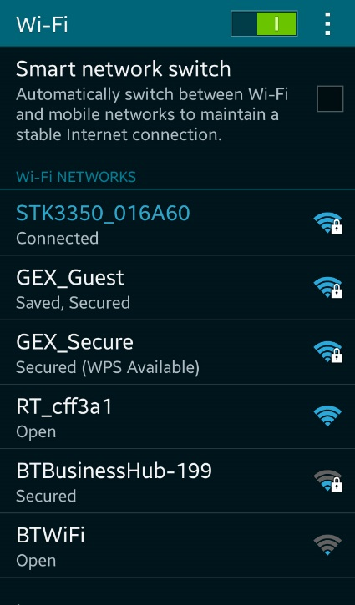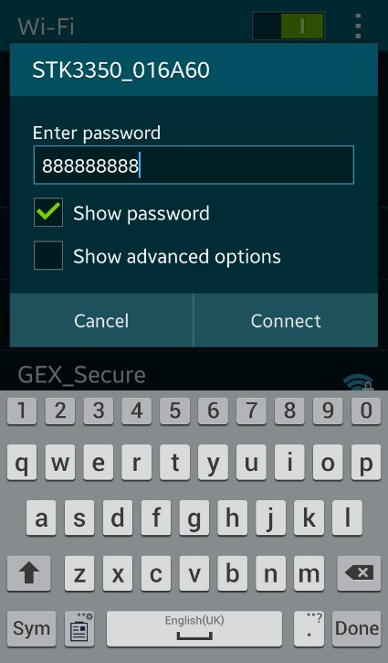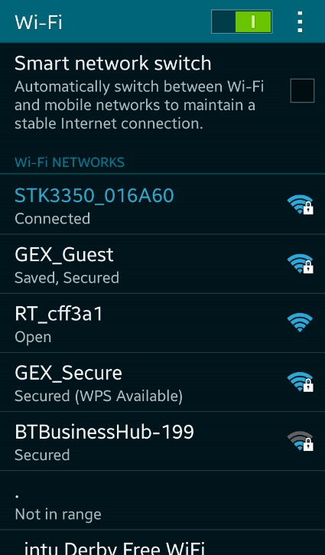
Figure 3 Figure 4 Figure 5
The Wifi will need to be connected to using a password which is 888888888 (nine eights).

Once connected to the camera you will need to open the P2PCamLive App on your phone. After the App has loaded you should be on the window “My Cameras” as shown in Figure 6.
Figure 6
To add the camera for the first time press the “Click here to add camera” option.
Figure 7 shows the options you will be faced with; you can press “Search” or “Scan” to find a new camera. The search option will bring up any camera available to connect to; tap the camera name to select it (Figure 8).
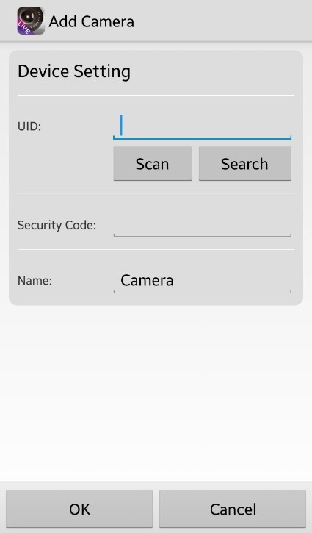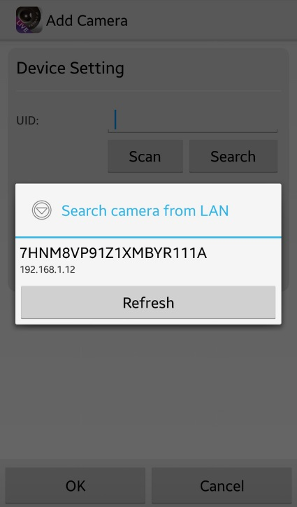
Figure 7 Figure 8
The scan option enables you to use your phone’s camera to scan the QR code on the bottom of the camera (Figure 9).
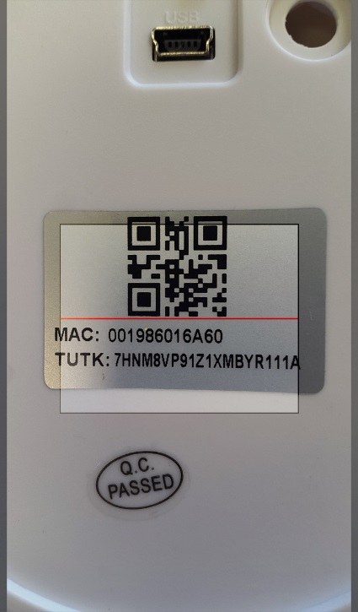
Figure 9
Once you have found the camera the default password is “888888” (six eights). You can also change the name of the camera (Figure 10), this is useful if you plan on having a number of the cameras connected. Once complete press “ok” and you will be taken back to the “My Cameras” screen; instead of being blank you should now have a camera available (Figure 11).
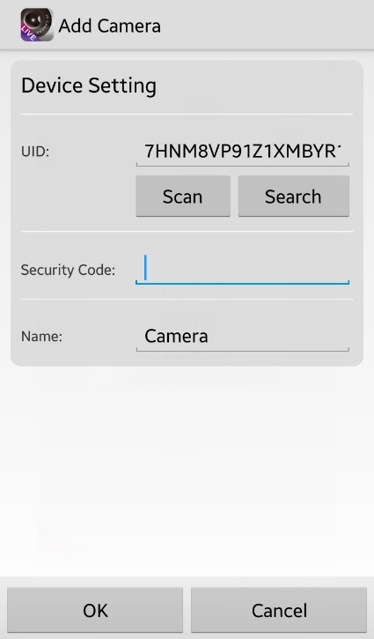
Figure 10 Figure 11
The camera is now connected to your phone/tablet.

Via Phone or Tablet (internet connect)
For this to work you MUST be connected to the camera directly and have it available in the “My Cameras” list.
Once you have your phone connected to the camera’s Wifi you can then connect it to your local network. To do this go to the following address in your phone browser http://10.10.10.254.
Once on this page navigate to “AP Client” under the “Wireless Settings” option on the left hand side (Figure 12).
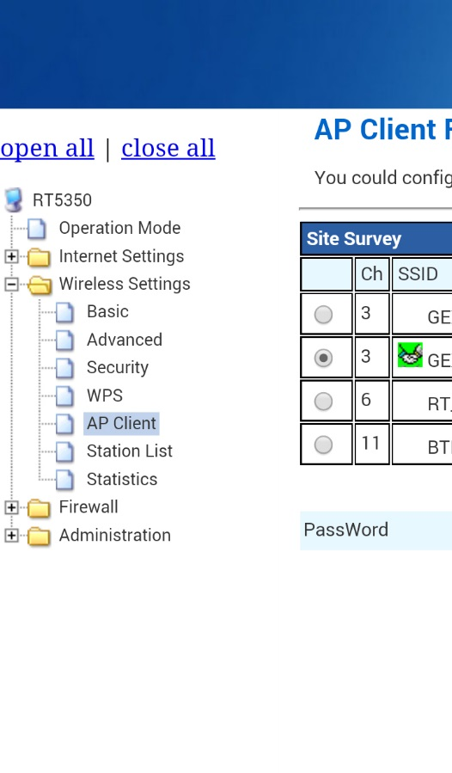
Figure 12

(turn over)
This will then bring up an available list of networks you can connect to (Figure 13). Select the network name you wish to connect to and enter the password.
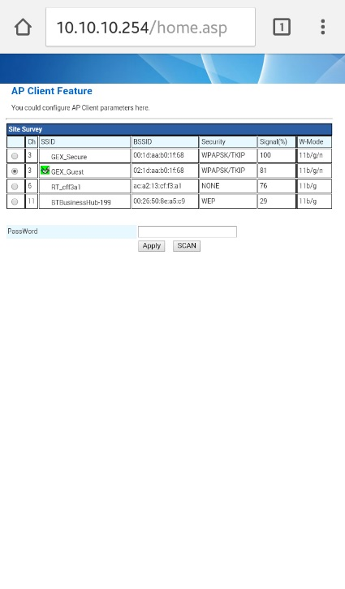
Figure 13
When you press the “apply” button the browser will look as though you have lost connection. This is because the phone is no longer connected to the cameras Wifi.
Connect your phone back to your own router, if it has not auto-connected by itself, and look in the “My Cameras” list to find the camera as connected and available to view.

(turn over)

Via Computer (LAN connect)
You can only use the software to view live and record footage on the computer. You will not have access to any of the camera settings.
First off you will want to have connected the camera to your wireless network, please follow the previous steps to connect directly via your phone/tablet and then connecting the camera to the Internet. When you have connected the camera to your Wifi you can open the P2PCamWin software.
Once open you should have a window as shown in Figure 14.
Figure 14
To add a camera to the viewing list you want to select the camera number you want to add it to and press the + icon highlighted in Figure 15.

Figure 15
This will bring up a small window (Figure 16) in the centre of your screen. From here you want to press the “search” button and it will scan the network for any camera devices that are connected to it; any devices found will appear in the upper box as shown in Figure 17.
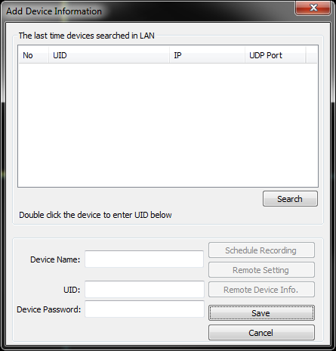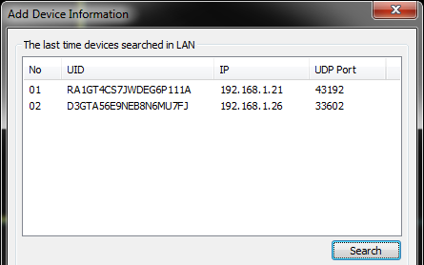
Figure 16 Figure 17
Double click the camera that you wish to connect and the UID in the bottom half the window will auto-fill. You will need to add a device name which can be anything; if you are going to be using multiple cameras then why not name them after the room they are in? You will also want to insert the password; by default this is 888888 (six eights).
Figure 18
After filling in the information click the “save” button, this will add the camera to the program and try to connect to it (this may take a moment).

When connected you will get a live video feed from the camera, much like the example in Figure 19.
Figure 19
You can have up to 16 cameras connected at once which is plenty should you wish to kit out a building.

(turn over)

Camera Settings
You can change the picture quality to get the best out of the camera. By default the camera will have a high setting on which is 640 x 480 but you can change it to max (1280 x 720) if you wish.
To do this, when in the “My Cameras” area, select the down arrow next to the camera. This will bring up a menu as shown in Figure 20. To change any settings go in to the “Edit Camera” menu.
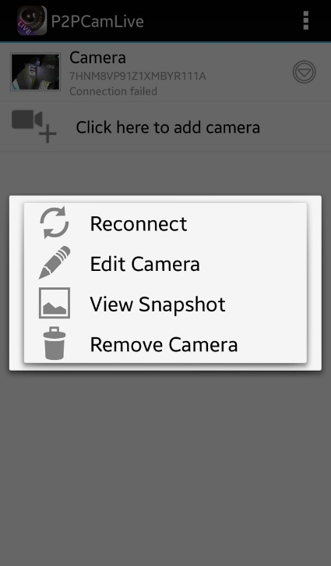
Figure 20

(turn over)

Here you can change the camera name or click the “advanced” button (Figure 21) to change the resolution as shown in Figure 22
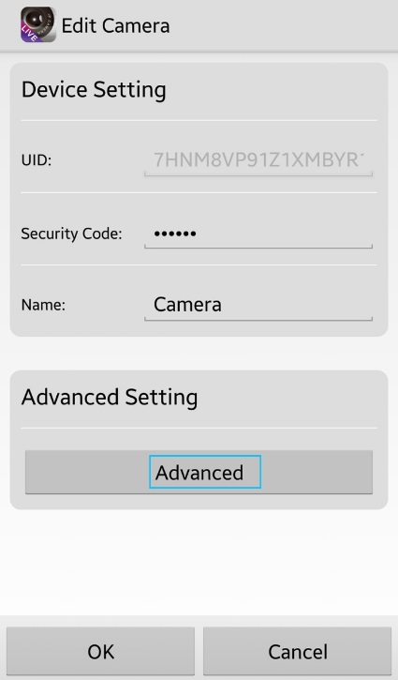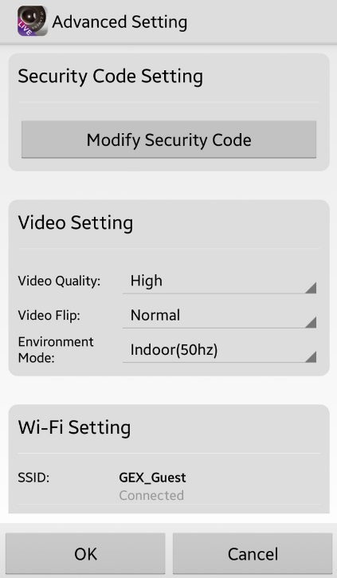
Figure 21 Figure 22

(turn over)

Live View

Via Phone or Tablet
You can view what it going on live simply by selecting a camera from the “My Cameras” list.

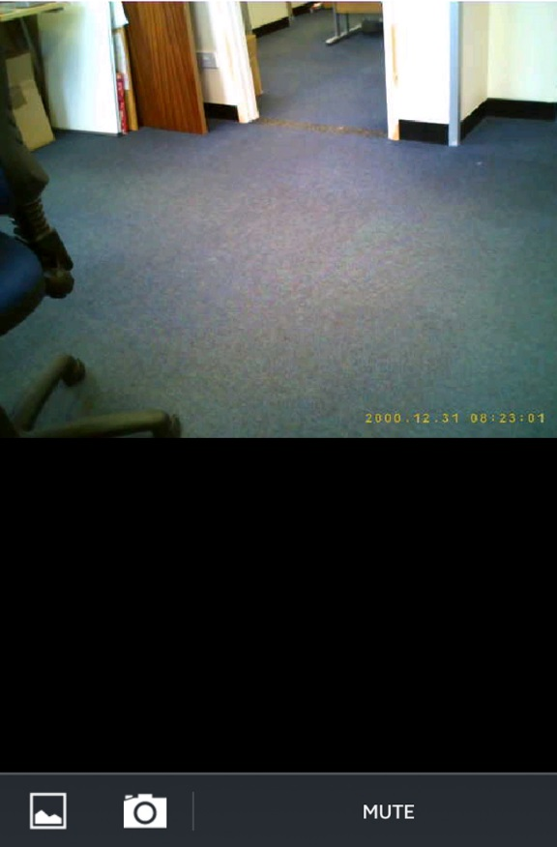
Figure 23
At the bottom of the live feed you get two options (Figure 23). The first option on the left is to view any screen captures you have already made. The second option will take a screen capture of the live feed.

(turn over)

Via Computer
In the bottom right corner of the live view pane you have some basic controls for that specific camera. From left to right, first is the record button. If you press the record button the software will save a video file to the computer.
Figure 24
The second option is used for adjusting the picture location. The third is to enable communication via the camera. The fourth is the receiving audio; this camera does not have a mic. You then have a photo button, press this to take photo which will be stored in the same place as the video. The last option will disconnect the camera.

(turn over)

Viewing Files

Via Phone or Tablet (camera screen captures)
To access any screen captures you have taken refer to Figure 23 and select the first option. This will bring up all the screen captures you have made (Figure 25). The app will also save the screen captures to your device in your pictures or gallery.
Figure 25

(turn over)

Via Computer (computer recordings)
To view the videos recorded press the “Browse” button in the top right corner of the P2PCamWin. This will bring up a mini menu with options, you want to click “Playback” as shown in Figure 26.
Figure 26
You will now have a window open (Figure 27) in the centre of the screen which will enable you to view recorded videos from all the cameras on your network. You can select the specific camera in the left column and then double click the file you want to view from the centre column.
The video will playback in the right column which can go full screen simply by double clicking the video pane.
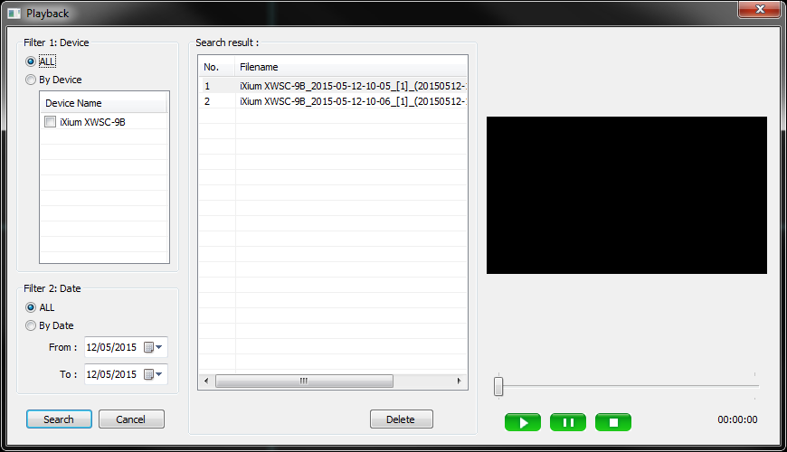
Figure 27
You can narrow down timeframes by using the filter in the lower section of the first column too; great if you have hundreds of hours of footage.

Still Struggling?
If you are still struggling to understand how this item works you can get in contact via the following methods.

Recommended
Contact the official stockist through the eBay or Amazon messaging system.

Other
Email: support@ixium.co.uk
Telephone: 0115 8716899

Appendix

P2PCamWin Install
Insert the disk or download the software from our website.
Locate the P2PCamWin install file (Highlighted in Install 1) and double click it.
Install 1
You will then get an install wizard (Install 2 to 6) which will then take you through the process of installing the software. Follow the steps and the software will install.
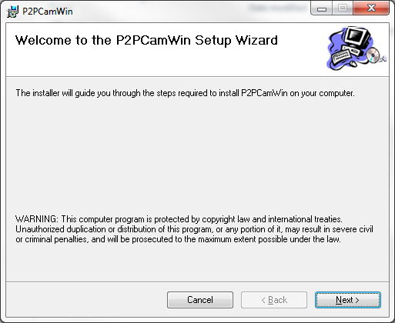
Install 2
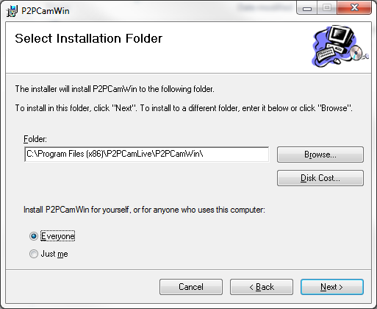
Install 3
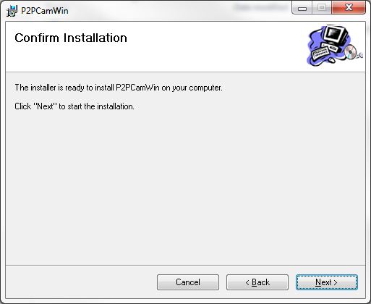
Install 4
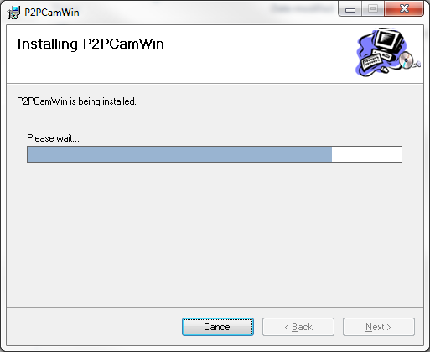
Install 5
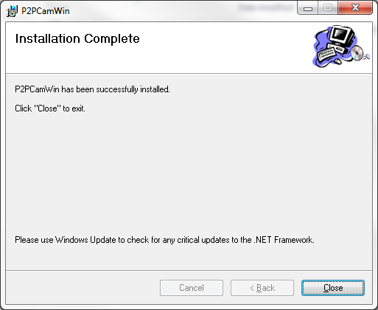
Install 6
The software is now installed and ready to open.

