ixium
Smiley Face Badge DVR Camera and MP3 Player
User Manual

Contents
Package Contents 2
Before You Start 2
Overview 3
Controls 3
SD Card Slot (TF) 3
USB: Syncing and Charging 3
2.5mm Jack 4
Power/Record 4
Video Mode 4
Audio Mode 4
MP3 Player 4
Play/Pause 4
Forward/Volume Up and Back/Volume Down 4
Timestamp Edit Error! Bookmark not defined.
Still Struggling? 8
Recommended 8
Other 8

Package Contents
- Smiley Face Badge DVR Camera and MP3 Player
- USB Cable (USB to mini USB)
- 2.5mm Jack Earphones

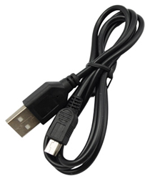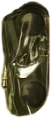

Before You Start
Make sure you have charged the device for 8 or more hours prior to full use.
It is recommended that you charge for 24 hours; however we know this is not always possible.
Turn over for charging instructions…

Overview
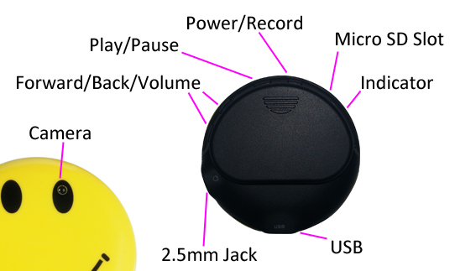
Figure 1
Figure 1 shows the controls that the badge uses. Nothing appears out of the ordinary, it looks and works just like a standard MP3 player badge. However it is packed full of useful features which enable anyone to monitor and record events.

Controls

SD Card Slot (TF)
You are able insert a Micro SD card (TF) up to 32GB into this badge.
When holding the badge with the back facing you, make sure the Micro SD card is facing down so the contact points are visible (Figure 2).
Figure 2

USB: Syncing and Charging
Insert the supplied USB cable that is supplied with the badge to charge the internal battery and transfer the files that are saved on the memory card.

2.5mm Jack
This is a standard 2.5mm Jack socket to plug any set of headphones that use a 2.5mm Jack plug (or the ones supplied). If you have an existing pair of 3.5mm Jack plug headphones then you are able to buy converters so you do not need to buy any new headphones.

Power/Record
The Power/Record button will turn the badge on and also capture videos and audio files.
To turn the badge on quickly press the Power/Record button, the indicator will turn red. It will flash once when ready.
To turn the badge off press and hold the Power/Record button for 4 seconds. The red indicator will go out and then come back on, once the indicator has come back on (this should be around 4 seconds) you can then let go of the button.

Video Mode
Start off by switching the badge on. Quickly press the Power/Record button and the indicator will flash quickly for a moment and then keep flashing slowly. The indicator will slowly flash for however long the badge is recording video for.
When you are done recording video quickly press the Power/Record button, the indicator will turn solid red and the badge will have stopped and saved the video recording.
You can now turn the badge off or use one of the other features.

Audio Mode
Start off by switching the badge on. Press and hold the Power/Record button for 2 seconds and the indicator will start flashing slowly. The indicator will slowly flash for however long the badge is recording audio for.
When you are done recording audio quickly press the Power/Record button, the indicator will turn solid red and the badge will have stopped and saved the audio recording.
You can now turn the badge off or use one of the other features.

MP3 Player

Play/Pause
Use this button the play and pause music that you have put onto the memory card.
To put music onto your badge memory card make sure you have inserted the memory card and plugged it into the computer via the USB cable supplied.
Open the ‘AUDIO’ folder on the badge and move your songs to the folder like you would with any other MP3 player or memory stick.

Forward/Volume Up and Back/Volume Down
These buttons move the track forward and back and adjust the volume. A quick press will skip track; holding and pressing the buttons will change the volume accordingly.

Timestamp Edit
You may need to update the internal clock for the timestamp shown in images and videos.
To do this, you will need to create a text file with the date and time.
- Plug the badge into your computer by using a USB cable.
- It will appear as a Removable Disk.
- Open the Removable Disk, you might have a text file called “setdate” already there.
- If you already have a file called “setdate” then move onto Step 7.
- Right click in the white space and a menu will appear (Figure 3), move down to “New” and select “Text Document”.

Figure 3
- A new Text document will appear (Figure 4) and give you the option to name it, call it “setdate”.
Figure 4
- Open the file and write the date and time in the following method:
2012-12-04 15:55:36
- Save and close the file.
- Unplug the camera from the computer and turn it on. The time is now updated.
- Plug the USB Stick back into your computer and delete the “setdate” file if still there.

(next page)

Still Struggling?
If you are still struggling to understand how this item works you can get in contact via the following methods.

Recommended
Contact the official stockist through the eBay or Amazon messaging system.

Other
Email: support@ixium.co.uk
Telephone: 0115 9899516

