Sportscam MiniDVR Manual
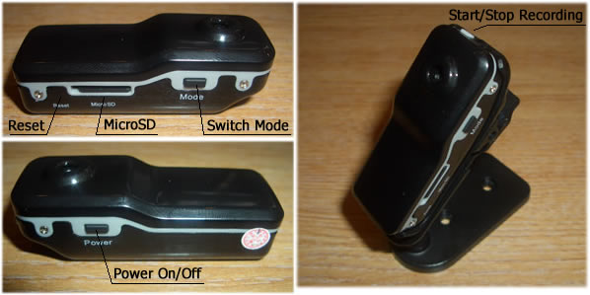

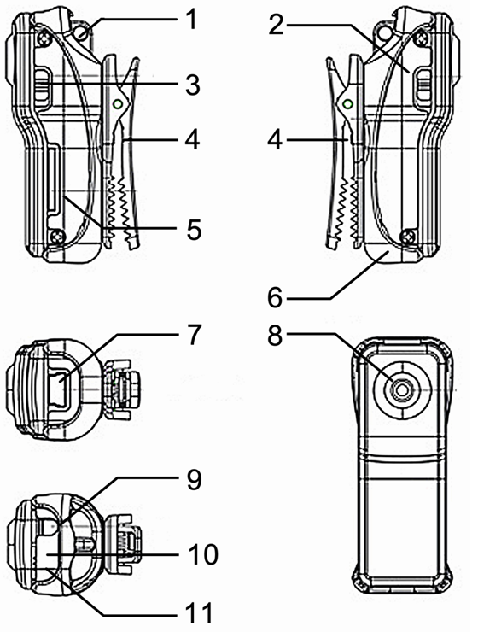 | Key:  - Lanyard Hole  - Power  - Mode  - Clip  - Micro SD  - Camera Holder  - MiniUSB Connection  - Camera Lens  - Power On/Off  - Status Indicator  - Microphone
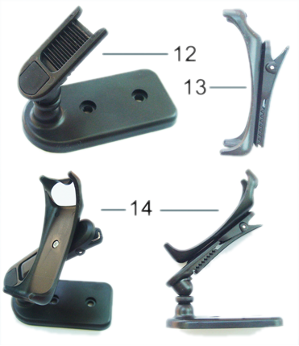 | - Clip Mount  - Clip  - Clip & Mount Connected
- Introduction
This mini DV recorder is a High Definition video recorder with simple operation and sound control. Its elegant design and small size make it easy to carry and can be an essential utility in business, education, security, media, justice, tourism, healthcare and entertainment.

- Operating Instructions
2.1 Charging
The built in lithium rechargeable battery is partly charged so will require a full charge before first use. Connect the MiniUSB cable to the device and plug into a spare USB port on a computer that is switched on. When on charge the red light comes on solid whilst the blue light flashes slowly. When the blue light stops flashing the unit is fully charged.
2.2 Power on to Video Recording
Press power button to turn the device on. The blue indicator will come on to indicate the device is on and in standby mode. Press the Stop/Record button once to begin recording. The red led now flashes to indicate the device is recording. Press the Stop/Record button again to stop recording video and the red light will stop flashing and return to a solid blue.
Notice:
a) Please make sure that a MicroSD card has been inserted. If no card is inserted when the device is turned on, the red light comes on solid and the blue light flashes continually.
b) The maximum capacity of the MicroSD card is 16GB
c) When you have finished recording and press stop, please remember the device will take a few moments to save the file. Avoid pressing the Stop/Record button continuously to avoid getting unsmooth and/or incomplete files.
d) When making a video, please keep focus on the object from a distance of at least 50cm under sufficient illumination. This will ensure bright clear and stable images are recorded.
2.3 Sound Control Video
To enable sound control mode, press the power button to turn the device on. The blue LED will come on solid to indicate standby mode. Now press the “Mode” button. The blue LED remains on whilst the red led begins to flash quickly. This indicates the camera is now in sound control mode. If a noise above 60 decibels is detected then video recording is started and the red led will flash slowly. If the sound level drops below 60 decibels for longer than 2 minutes, recording will stop and the red light will return to rapid flashing to indicate the device is back in standby mode and waiting for more sound.
2.4 Setting The Time for the OSD
On the included disc is a file called TAG.TXT. To change the time, open the TAG.TXT file and edit the date/time. Place a copy of the file on the ROOT* directory of your MicroSD card. The next time the DVR is activated it will read the TAG.TXT file, alter the internal clock and then delete the file from the memory card.
2.5 Power Off
Under video mode or standby mode, press power button down for 3 seconds until the indicator light goes out. The device is now powered down.
2.6 Auto Power Off
The device will auto power down under the following circumstances:
a) If the device runs out of power whilst shooting video the file will be saved and the device will power down.
b) When there is not enough space on the MicroSD the file will be saved automatically and the device will power down.
c) When in standby mode, if the device is idle for 45 seconds it will auto power down.
2.7 Connecting To Computer
Connect the included MiniUSB cable to the device and then connect to a spare USB port on a computer that is switched on. Under any version of Windows from XP service pack 2 and onwards, the required ‘Mass Storage’ drivers are automatically installed. A new drive will appear under “My Computer” – this is the MicroSD card installed in the device.
Please Note: (a) If the MicroSD card is not showing after ~30 seconds, disconnect and then reconnect the device. (b) It is recommended that you copy the files from the MicroSD card to your computer before trying to open them.
2.8 WEBCAM Mode/ PC Camera
Before trying to use the device as a webcam, please run the installer from the included disc, titled “SPCA1528_V2220_M…Setup.exe”. This will install the appropriate drivers to allow the unit to be used as a webcam. After installation there will be a program called “AMCAP” on the desktop and/or in the start menu. This program will allow you to monitor the capture of the camera. The device can now be used in MSN, Skype, and other video calling or video capture applications.
Please Note: Only 1 video capture application can access the camera at the same time. For example, if you have AMCAP open monitoring your camera and try and use Skype, Skype will not be able to access the camera until AMCAP is closed.

3. Device Details
Feature | Details
Video Format | AVI
Video Encoding | M-JPEG
Video Resolution | 720*480 VGA
Video Frame Rate | 30FPS ± 1fps
Media Playing Software | VLC Media Player Recommended
Image Ratio | 4:3
Supported OS’s | Windows XP/Vista/Win7 32bit
Charging Voltage | DC-5V
Interface Type | MiniUSB 5 pin
Storage Support | MicroSD memory card
Battery Type | High Capacity lithium polymer

