ixium
DVR Mini Camera
User Manual

Contents
Package Contents 2
Before You Start 2
Overview 3
Controls 4
SD Card Slot (TF) 4
USB: Syncing and Charging 4
Microphone 4
On/Off 4
Video Mode 4
Camera Mode 5
Audio Mode 5
Motion Detection Mode 5
Timestamp Edit 6
Still Struggling? 8
Recommended 8
Other 8

Package Contents
- DVR Mini Camera
- USB Cable (USB to Mini USB)
- Mobile Charging Unit with Cable

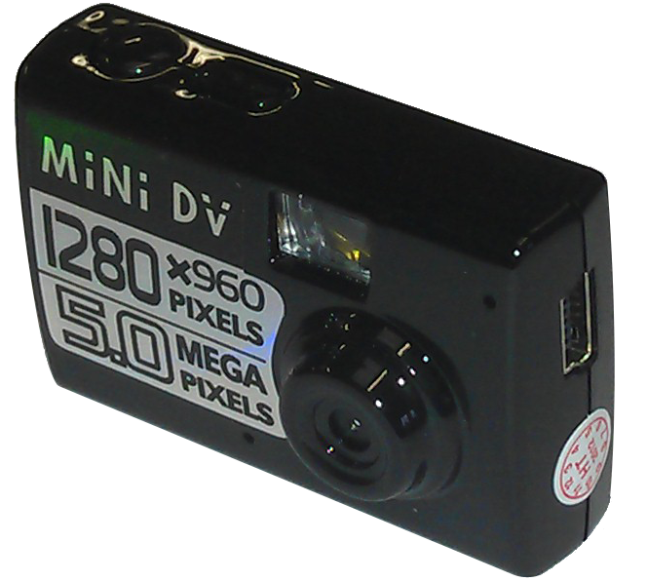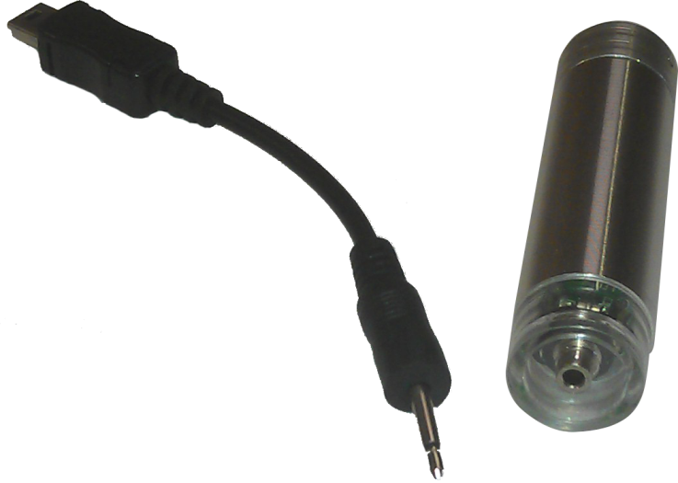

Before You Start
Make sure you have charged the device for 8 or more hours prior to use.
It is recommended that you charge for at least 24 hours; however we know this is not always possible.
Turn over for charging instructions…

Overview

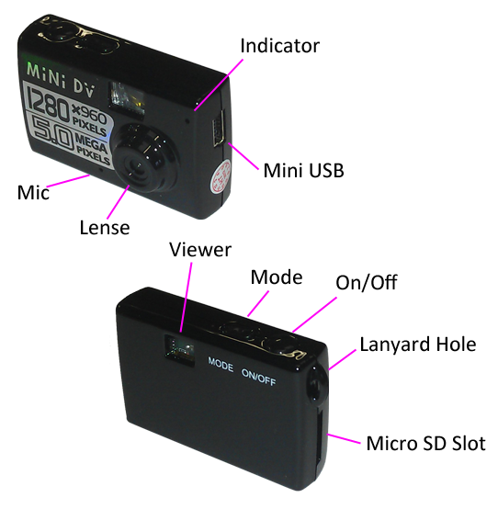
Figure 1
Figure 1 shows the controls that the mini camera uses.

Controls

SD Card Slot (TF)
You are able insert a Micro SD card (TF) up to 32GB into this camera.
When holding the camera with the front facing you, make sure the Micro SD card is facing down so the contact points are visible (Figure 2).
Figure 2

USB: Syncing and Charging
Supplied with the mini camera is a USB cable which enables you to charge the battery and transfer the files that are saved on the Micro SD Card.

Microphone
The microphone works just like any other; it will capture the sound for the videos and audio recorder

On/Off
To turn on simply press and hold the power button for 1-2 seconds and the indicator will light up blue then red. Wait until the indicator has turned red and you are ready to use the camera.
Again to switch the device off press and hold the power button for 2-3 seconds and the indicator will go out.

Video Mode
Turn the mini camera on. When on the indicator should be red, quickly press power button and the indicator will flash red which means it is recording.
When you are done recording video quickly press the power button and the red indicator will come back on solid.
You can turn the camera off or use one of the other features when done taking videos.

Camera Mode
Turn the mini camera on. When on, quickly press mode button and the indicator will light up blue. To take a picture, quickly press the power button and the indicator will go out and light up blue again when ready to take the next photo.
You can turn the camera off or use one of the other features when done taking photos.

Audio Mode
Turn the mini camera on. When on, quickly press mode button as if you were going to take a photo, then quickly press the mode button again and the indicator will turn blue/red. To capture audio, quickly press the power button and the indicator will flash blue/red which means it is recording.
When you are done recording audio quickly press the power button and the blue/red indicator will come back on solid.
You can turn the camera off or use one of the other features when done taking audio.

Motion Detection Mode
Make sure the camera is off. Press and hold the power button for 3-4 seconds, this will go straight into motion detection mode; the indicator should be blue and flashing red.
When you are done recording quickly press the power button and the red indicator will come back on solid.
You can go back into recording in motion detection mode by quickly pressing the power button.
To get back to the other features you simple turn the camera off and then back on.

Timestamp Edit
You may need to update the internal clock for the timestamp shown in images and videos.
To do this, you will need to create a text file with the date and time.
- Plug the camera into your computer by using a USB cable.
- It will appear as a Removable Disk.
- Open the Removable Disk, you might have a folder called _REC and a text file called “time” already there.
- If you already have a file called “time” then move onto Step 7.
- Right click in the white space and a menu will appear (Figure 3), move down to “New” and select “Text Document”.

Figure 3
- A new Text document will appear (Figure 4) and give you the option to name it, call it “time”.
Figure 4
- Open this TIME file and write the date and time in the following method:
2010.01.26 10:10:59 Y (this is example only, use the correct date/time)
2010.01.26 10:10:59 N (Y to display timestamp, N to not display timestamp)
- Save and close the file.
- Unplug the camera from the computer and turn it on. The time is now updated.
- Plug the USB Stick back into your computer and delete the TIME file if still there.

(next page)

Still Struggling?
If you are still struggling to understand how this item works you can get in contact via the following methods.

Recommended
Contact the official stockist through the eBay or Amazon messaging system.

Other
Email: support@ixium.co.uk
Telephone: 0115 9899516

