ixium
iXKIR720 HD Key Fob Camera
User Manual

Contents
Package Contents 2
Before You Start 2
Overview & Basic Setup 3
Battery and Charging 3
Inserting the Memory Card 3
Reading the Memory Card 4
Operation Instructions 4
Turn the Key Fob On and Off 4
Recording a Video 4
Taking a Picture 4
Recording a Motion Activated Video 4
Toggle Night Vision 4
Timestamp Edit 5
Still Struggling? 7
Recommended 7
Other 7

Package Contents
- iXKIR720 HD Key Fob Camera
- USB Cable (USB to Mini USB)

Before You Start
Make sure you have charged the device for 8 or more hours prior to use.
It is recommended that you charge for at least 24 hours; however we know this is not always possible.
You must insert a Micro SD memory card with free space before using this device
Turn over for charging instructions…

Overview & Basic Setup
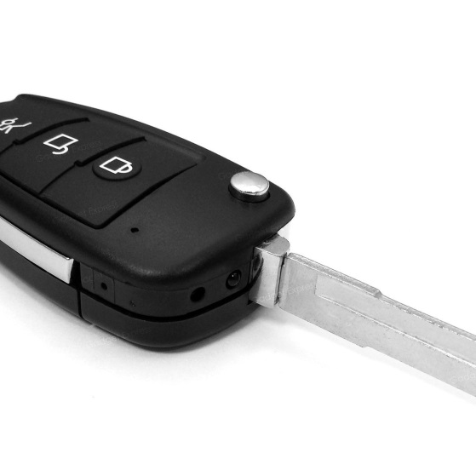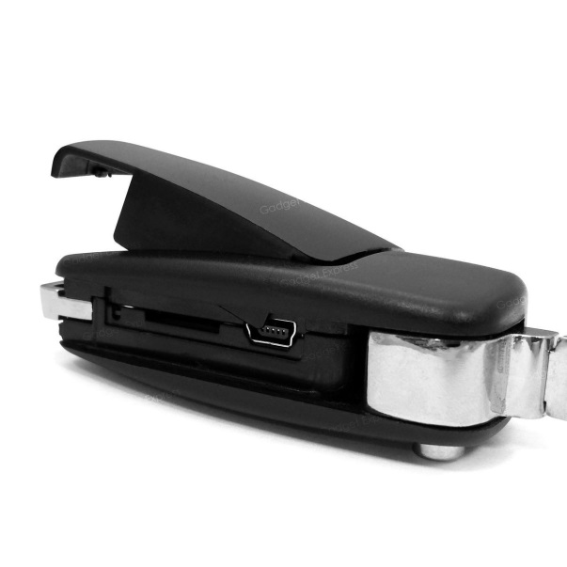
IR
Lens
Audio/Video
LED indicator
Motion Detection/IR
Power
Mini USB port
MicroSD Card Slot
Figure 1

Battery and Charging
Supplied with the key fob is a USB cable which enables you to charge the internal battery. This can be done via a computer or a USB mains charger. Whilst on charge, the LED indicator will flash purple.

Inserting the Memory Card
For the key fob to record any footage you must insert a Micro SD card; you can use any Micro SD card between 4GB and 32GB. If you need a Micro SD card then take a look here: www.wecostless.co.uk > electronics > memory cards
To insert a memory card into the device, first observe the card slot on the side of the key fob. Insert the memory card with the contacts facing up and push until it clicks into place.
Figure 2

Reading the Memory Card
Connect the key fob via the included USB cable to a USB port on your desktop or laptop computer. You may see a message in the system tray about “Installing Device Drivers”. You will then see an “Autoplay” window open which will allow you to access the inserted memory card. If the autoplay window does not open it may be due to your settings. You can still access the memory card by going to “My Computer” and then double clicking the appropriate removable device.
If you are unsure which device is your card then do the following. Open the “My Computer” window and observe the contents. Plug in the key fob and you will see the Removable Device appear in the window. Please allow up to 30 seconds for the device to appear.

Operation Instructions

Turn the Key Fob On and Off
Press and hold the Power button for 3 seconds and let go. You should see a purple LED which then changes to solid red - the key fob is now in standby mode.
When the key fob is on standby mode, press and hold the Power button until the LED goes out - the key fob is now off.

Recording a Video
When the key fob is in standby mode, press and hold the Audio/Video button. The LED will flash and then go out – the key fob is now recording a video. Press the button again to stop recording. The LED will turn red – the key fob is now in standby mode.

Taking a Picture
When the key fob is in standby mode, press the Audio/Video button. The LED will go off and come back on red – the key fob has taken a picture.

Recording a Motion Activated Video
When the key fob is in standby mode, press and hold the Motion Detection/IR button. The LED will flash and then go out – the key fob will now record when motion is detected. After three minutes has passed with no motion detected, the key fob will stop recording and return to motion detection mode. Press the button again to exit motion detection mode. The LED will turn red – the key fob is now in standby mode.

Toggle Night Vision
When the key fob is in standby mode, press the Motion Detection/IR button to toggle night vision on and off. Please be advised that there is no indication of whether the night vision is on or off, so try to keep track of how many times you’ve pressed the button.
When you turn on the key fob, night vision is off by default.

Timestamp Edit
You may need to update the timestamp shown on the key fob’s images and videos.
To do this, you will need to create or edit a Text file with the date and time.
- Plug the key fob into your computer by using a USB cable.
- It will appear as a Removable Disk.
- Open the Removable Disk; you might have some folders and a text file called “time.txt” already there.
- If you already have the text file then move onto Step 7.
- Right click in the white space and a menu will appear (Figure 2), move down to “New” and select “Text Document”.
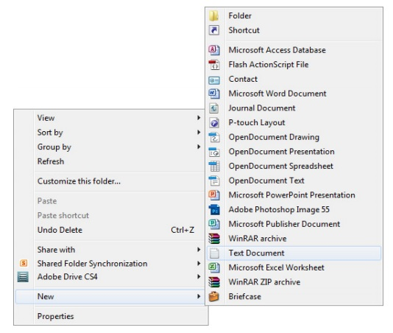
Figure 3

- A new Text document will appear (Figure 3) and give you the option to name it, call it “time”.
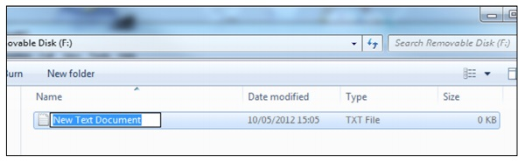
Figure 4
- Open this time file and write the date and time in the following format:
2012.05.19 09:46:11
- Save and close the file.
- Unplug the key fob from the computer and turn it on. The time is now updated.

Still Struggling?
If you are still struggling to understand how this item works you can get in contact via the following methods.

Recommended
Email: support@ixium.co.uk

Other
Telephone: 0115 8716899

