ixium
DVR Smoke Alarm
User Manual
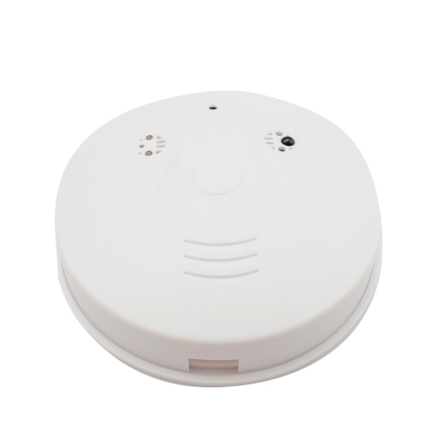
Contents
Package Contents 2
Before You Start 2
Overview: Smoke Alarm 3
Controls: Smoke Alarm 3
On/Off Switch 3
SD Card Slot (TF) 4
USB: Syncing and Charging 4
Microphone 4
Overview: Remote 5
Controls: Remote 5
On/Off 5
Camera Mode 5
Video Mode 5
Audio Mode 6
Motion Detection Mode 6
Timestamp Edit 7
Still Struggling? 9
Recommended 9
Other 9

Package Contents
- DVR Smoke Alarm
- USB Cable (USB to Mini USB)
- Remote Control

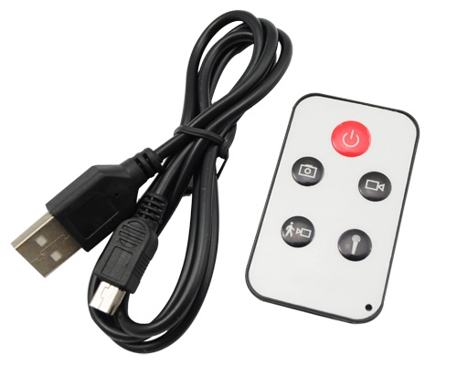

Before You Start
Make sure you have charged the device for 8 or more hours prior to use.
It is recommended that you charge for at least 24 hours; however we know this is not always possible.
Turn over for charging instructions…

Overview: Smoke Alarm

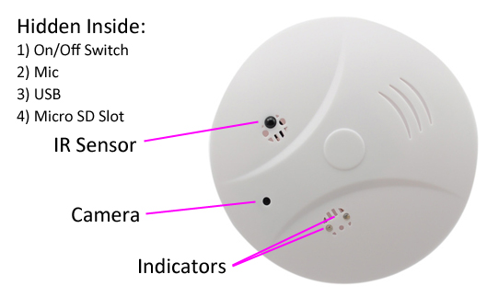
Figure 1
Figure 1 shows the controls that the smoke alarm uses. Nothing appears out of the ordinary, it looks just like a standard smoke alarm. However it is packed full of useful features which enable anyone to monitor and record events.

Controls: Smoke Alarm

On/Off Switch
This is a flick switch. Flick it one way for On and the other way for Off. These positions are labelled next to the switch, so you know which way is which.

SD Card Slot (TF)
You are able insert a Micro SD card (TF) up to 32GB into this smoke alarm.
When holding the smoke alarm with the back facing you, make sure the Micro SD card is facing down so the contact points are visible (Figure 2).
Figure 2

USB: Syncing and Charging
Supplied with the key fob is a USB cable which enables you to charge the battery and transfer the files that are saved on the Micro SD Card.
To charge and sync the smoke alarm make sure the On/Off switch is in the off position.
To access the files on the SD card, plug the smoke alarm in to your computer. The red indicator should be on solid. The SD card is being read by your computer and will come up as a removable disk.

Microphone
The microphone works just like any other; it will capture the sound for the videos and audio recorder

Overview: Remote
Figure 3 shows the controls that are on the remote.
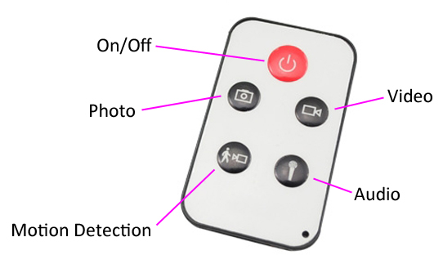
Figure 3

Controls: Remote
These buttons enable you to switch between the camera, video and audio recorder features depending on what you need.

On/Off
To turn on simply press and hold the power button for 2-3 seconds and the yellow indicator will light for 2-3 seconds, flash once, and then remain solid. You are ready to use the smoke alarm.
To switch the device off follow the same process and the yellow indicator will go out.

Camera Mode
Turn the smoke alarm on. When on, quickly press the photo button and the yellow indicator will flash once, then return to solid. This indicates the smoke alarm is ready to take another photo.
You can turn the smoke alarm off or use one of the other features when done taking pictures.

Video Mode
Turn the smoke alarm on. When on, quickly press the video button and the yellow indicator will flash and then go out. The smoke alarm might look like it is not doing anything; however, it is now recording video.
You can check whether it is still recording video by quickly pressing the audio button and the red indicator should flash.
When you are done recording video quickly press the video button and the yellow indicator will come back on solid.
You can turn the smoke alarm off or use one of the other features when done taking videos.

Audio Mode
Turn the smoke alarm on. When on, quickly press the audio button and the yellow and red indicators will flash simultaneously. The smoke alarm is now recording audio.
When you are done recording audio quickly press the audio button and the yellow indicator will come back on solid.
You can turn the smoke alarm off or use one of the other features when done taking audio.

Motion Detection Mode
Turn the smoke alarm on. When on, quickly press motion detection button and the yellow indicator will begin flashing slowly. The smoke is currently awaiting movement.
Once it detects movement, the yellow indicator will quickly flash and then go out, it is now recording video, having detected movement.
When you are done recording quickly press the motion detection button and the yellow indicator will come back on solid.
You can turn the smoke alarm off or use one of the other features when done taking motion detection videos.

Timestamp Edit
You may need to update the internal clock for the timestamp shown in images and videos.
To do this, you will need to create a Text file with the date and time.
- Plug the device into your computer as previously instructed.
- It will appear as a Removable Disk.
- Open the Removable Disk; you might have some folders and a text file called “time” already there.
- If you already have the text file then move onto Step 7.
- Right click in the white space and a menu will appear (Figure 3), move down to “New” and select “Text Document”.

Figure 4
- A new Text document will appear (Figure 4) and give you the option to name it, call it “time”.
Figure 5
- Open this time file and write the date and time in the following method:
2012-05-19 09:46:11
- Save and close the file.
- Unplug the device from the computer and turn it on. The time is now updated.
- Plug the device back into your computer and delete the text file if still there.

Still Struggling?
If you are still struggling to understand how this item works you can get in contact via the following methods.

Recommended
Contact the official stockist through the eBay or Amazon messaging system.

Other
Email: support@ixium.co.uk
Telephone: 0115 8716899

