ixium
Q5 Mini Thumb DVR Camera
User Manual

Contents
Package Contents 2
Before You Start 2
Overview 3
Controls 3
Charging/Syncing Port 3
Mode Button 4
Camera Mode 4
Motion Detection Video Mode 4
Audio Mode 4
Timestamp Edit 5
Still Struggling? 7
Recommended 7
Other 7

Package Contents
- DVR Camera
- USB Cable
- Wrist strap

Before You Start
Make sure you have charged the device for 8 or more hours prior to use.
It is recommended that you charge for at least 24 hours; however we know this is not always possible.
Turn over for charging instructions…

Overview

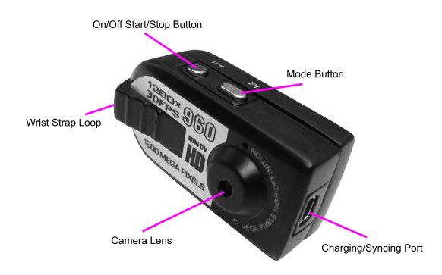
Figure 1
Figure 2
Figure 1 shows the item and its features.
Figure 2 shows the back of the item and its features.

Controls

Charging/Syncing Port
Use the USB Cable provided to Sync and Charge this item. Please note: You will only be able to Sync if an SD Card is in the item. When charging the Indicator will flash Red, when the item is fully charged the indicator will stay solid Red.

Mode Button
These buttons enable you to switch between the Camera, Video and Audio Modes depending on which you need. By pressing this button you can scroll between the modes. Each mode is identified by a different light.

Photo Mode
Press and hold the On/Off Start/Stop Button until the Indicator shows a steady Blue and Red Light. The item is now on. Now Scroll through the Modes by pressing the Mode Button until the Indicator shows a solid Blue light. You are now in the right Mode. Now press the On/Off Start/Stop Button once to commence the function, press it a second time to end it. When you are taking a Photo the light will momentarily go out when it is taking a Picture.

Video Mode
Press and hold the On/Off Start/Stop Button until the Indicator shows a steady Blue and Red Light. The item is now on. Now Scroll through the Modes by pressing the Mode Button until the Indicator shows a solid Red light. You are now in the right Mode. Now press the On/Off Start/Stop Button once to commence the function, press it a second time to end it. When you are filming the Red light will flash slowly.

Audio Mode
Press and hold the On/Off Start/Stop Button until the Indicator shows a steady Blue and Red Light. The item is now on. Now Scroll through the Modes by pressing the Mode Button until the Indicator shows a solid Blue and Red light. You are now in the right Mode. Now press the On/Off Start/Stop Button once to commence the function, press it a second time to end it. When you are recording Audio the light will flash Blue.

Motion Detection Video Mode
Press and hold the On/Off Start/Stop Button until the Indicator shows a steady Blue and Red Light. The item is now on. Now Scroll through the Modes by pressing the Mode Button until the Indicator shows a solid Blue light with a flashing Red light next to it. This has started Motion Detection mode. When the Light is flashing Red with the solid Blue light next to it the Camera is filming, it will continue to film if Motion is detected.

Timestamp Edit
You may need to update the internal clock for the timestamp shown in images and videos.
To do this, you will need a small program that will access the clock on your computer and transfer the data to the watch.
PLEASE NOTE: Your virus scan might think this is a virus; however, we can assure you that this is not the case.
You might need to tell your virus scan program to ignore the threat. Or to disable your virus scan program temporarily.
**due to the varied nature of virus scans we cannot help you through this part of the process**

(next page)

Plug the watch into your computer and download the drivers/software from www.ixium.co.uk/downloads.php
Once you have downloaded the file find and run WriteTime_Ch.exe which is included in the download.
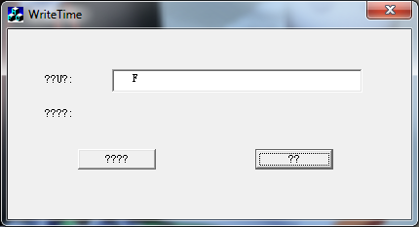
Figure 2
You should now have a window that looks like Figure 2. You may have foreign symbols or question marks depending, this does not matter because the program will still work.
Click the button highlighted in blue and a window (Figure 3) will appear.
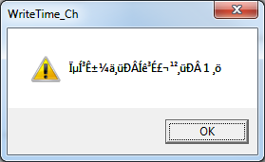
Figure 3
The time files have now been put onto the watch. Click OK and then click the button highlighted in red from Figure 2.
Unplug the watch from your PC and turn it on.
The timestamp has now been updated.

Still Struggling?
If you are still struggling to understand how this item works you can get in contact via the following methods.

Recommended
Contact the official stockist through the eBay or Amazon messaging system.

Other
Email: support@ixium.co.uk
Telephone: 0115 8716899

