iXium Video Capture Device 2015

Honestech VHS to DVD 3.0 SE

Quick Setup Sheet

Thank you for your purchase of the iXium 2015 Plug & Play Video Capture Device. Please follow the steps below to get the device installed and if you have any trouble, please give our technical support team a call on 01158716899 and we’ll get you up and running in no time. We also have video tutorials for the device on our YouTube support channel: https://www.youtube.com/user/IxiumSupport

1. Insert the disc into your CD drive OR download the software from our support website: http://ixium.co.uk/ebsupport.html You may be presented with the window below – select “Run autorun.exe”
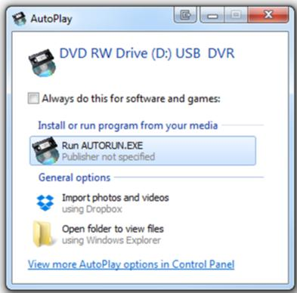

- The autorun menu will appear as pictured below, first select “install Driver” and follow the on-screen instructions. Once the driver installation is complete please select “Install Applications” and follow the installation wizard. Now that the Driver and Application have been installed you can press Exit.
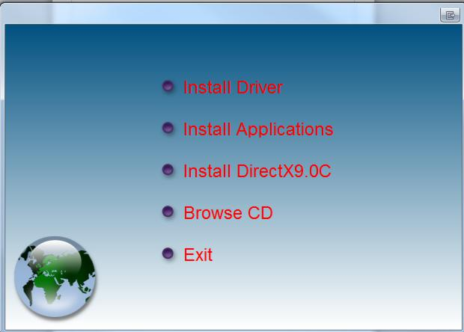

- Once completed you will be presented with an Icon on your desktop called “Honestech VHS to DVD 3.0 SE”. DO NOT RUN THIS PROGRAM YET.

- Connect the capture device to your PC*. It will automatically install the drivers. This may take a few seconds to a few minutes depending on your system. You can check that it has completed installing the drivers by looking in device manager for “SMI GRABBER DEVICE” OR “USB 2.0 Camera” under the heading “Sound, video and game controllers”.
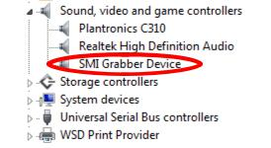

- You can now run the “Honestech VHS to DVD 3.0 SE” shortcut from your desktop. You will be asked for the serial key which

is: VHS3G-NMLGG-HGGGE-82A42-DBMGD

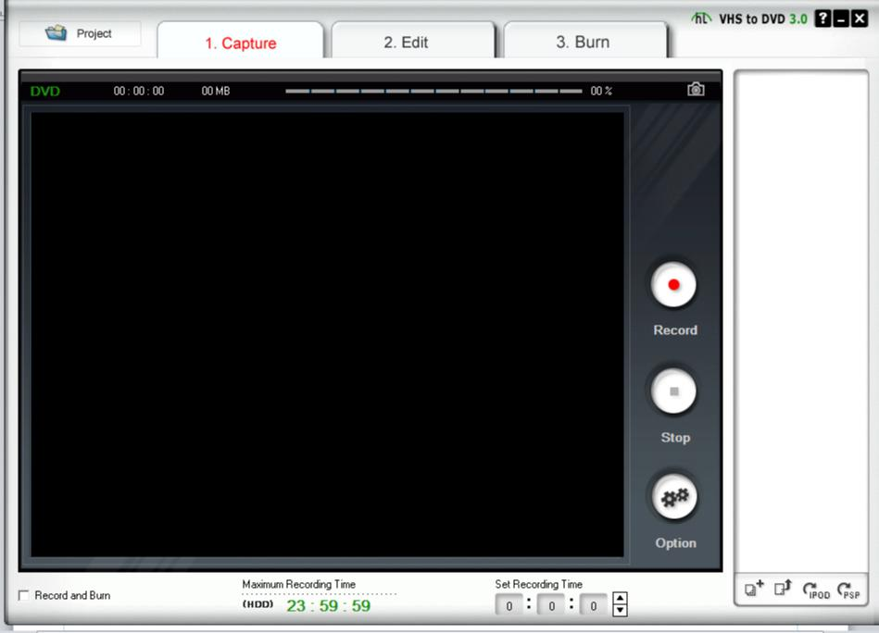

- Once you have launched the software you will see the screen as pictured above. Connect up the capture device to the input source e.g. VHS Player, Camcorder etc, using the red, white and yellow or s-video connectors, and in the preview window you will see the live feed of your video source.
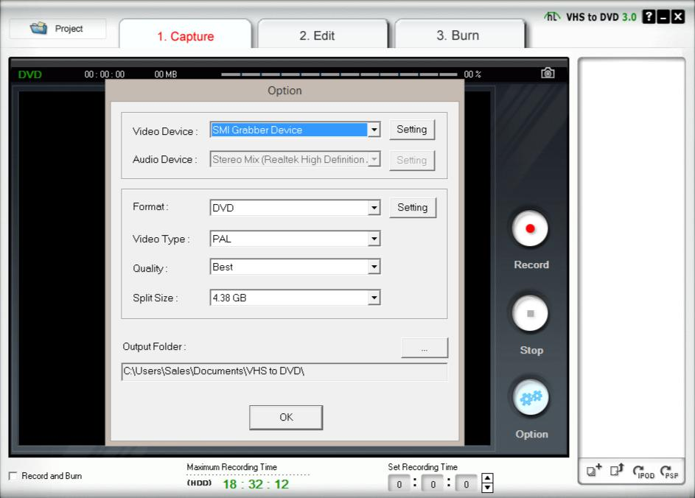

- Before we start capturing video you need to make sure all the settings are correct. Press the options button and a pop up window will appear. Make sure that the settings are all the same as the ones in the picture above. The Audio Device menu will be Greyed Out and does not need to be altered. From here you can also change the location where the videos are saved by going to the output folder menu.

- Now that you have updated the settings simply press the record button and you will start capturing the video, once you have finished recording press the stop button and it will save the video to the specified output folder.

From here you can do anything you like with your videos using your favourite editing suite. You could upload them to YouTube or Facebook or even make your own DVD for which we recommend Windows DVD Maker. Just don’t forget to make the DVD in “Video Disc“ mode and not “Data Disc”!

For more help email us at support@ixium.co.uk or you call our support team 01158716899. We also have a YouTube tech support channel: https://www.youtube.com/user/IxiumSupport

- If the driver does not install correctly, try connecting the device directly to your PC without using the small USB port extension cable and try a different USB port. If you continue to have issues installing the device itself, please contact us using the details above.

